|  |  |
| --- | --- |
| Date: |  |
| Title: |  |
| Notes: |  |







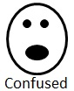

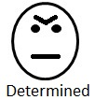

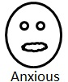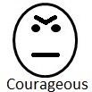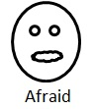

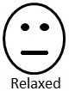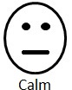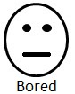

Click on the word “Custom” and change it to whatever emotion you want.

Slide the emoticon and the feelings word separately onto the target shape.

Custom

Custom



Custom

Custom